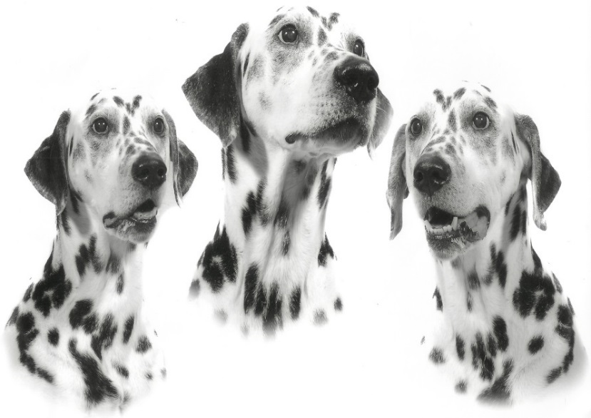
WANTED
Used postage stamps: GB and Foreign, Post Office Package Labels (Gold/White), empty postage stamp books and old postcards
British Dalmatian Welfare is a UK Charity dedicated to the welfare and rehoming of the Dalmatian breed. Run by volunteers it offers advice and support to owners and finds new families for dogs that can no longer stay in their homes.
Please give to:

Or post to: K Rose, 20 Applefield Road, Drimpton, Beaminster, Dorset, DT8 3RY
Thank you
British Dalmatian Welfare www.dalmatianwelfare.co.uk

Registered Charity No 108651

